

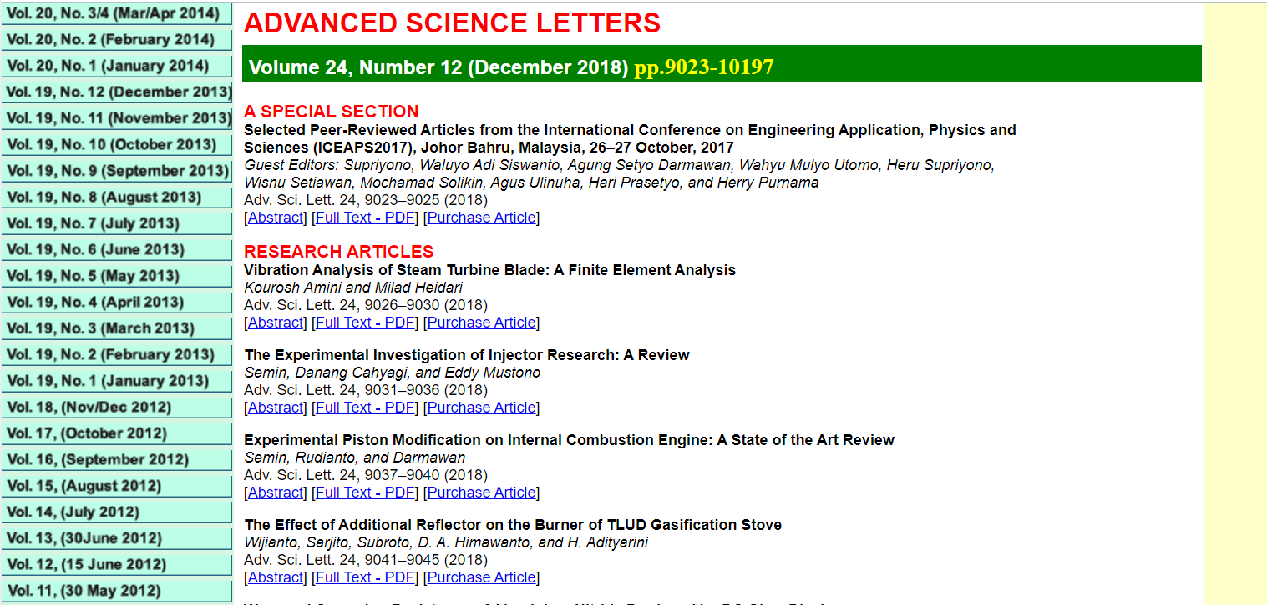



**Modification Of Plugging Sensor Addition On Inlet Coal Pulverizer In PT PJB UBJOM PLTU Indramayu**

Syarif Hidayata, Gregorius Sutrisnob

*aDepartment of Electrical Engineering, School for Engineering of PLN’s Foundation, Jakarta 11750, Indonesia*

*bDepartment of Electrical Engineering, School for Engineering of PLN’s Foundation, Jakarta 11750, Indonesia*

*Corresponding author Email :* [*asyarifhidayat@sttpln.ac.id*](mailto:asyarifhidayat@sttpln.ac.id)*, bgregorius@sttpln.ac.id*

*Received: October 3rd 2017*

Coal is one type of fuel that can produce efficient combustion. One of the steam power plants that use coal as fuel to generate electricity is PLTU UBJOM Indramayu. In PLTU UBJOM Indramayu coal to be used as fuel has passed through several processes to form a coal powder ready to use for combustion. Initially the coal that is accommodated in the coal bunker will be smoothed by using a coal pulverizer where the amount of coal coming into the coal pulverizer is set in the coal feeder in control of the control room. At the time of this process of coal refinement, coal in the coal feeder will go to coal pulverizer inlet often experience plugging. The case of plugging here is when the wet coal conditions attached to the coal pulverizer inlet and accumulate so that the flow of coal to the coal pulverizer occurs interference. Due to a disruption, the fuel supply used for the burning process in the boiler will decrease which in the end the unit experiences derating. To handle plugging problems like this, it can be done with the addition of mounting sensors that can monitor pulverizer conditions. This sensor can detect the occurrence of coal deposits inside the coal pulverizer inlet and when the buildup occurs, the coal feeder must be closed immediately to accelerate the recovery of coal pulverizer.

**Keywords:** Coal Pulverizer, Coal Plugging, Derating.

1. Introduction

Since starting operations in 2012, PLTU Indramayu experienced several operational technical problems in all units, either Unit 1, 2 or 3. Some problems have a very significant effect on the financial loss of the company. The next discussion gives special emphasis to the problem of coal plugging, which has become a major problem that is always repeated and very detrimental to the company because the unit resulted in derating. The low quality of coal caused by the high quantity of coal ash, wet (high moisture) of coal and the inner surface of coarse coal pulverizer inlet can cause the phenomenon of "coal plugging". Coal plugging is a condition where coal supply from coal bunker to coal feeder, or from coal feeder to coal pulverizer stops completely because the wet coal flow attached to the inner wall is hardened to become a coral. These corals gradually enlarged to close the entire cavity and ultimately hinder the flow of coal in total.

1. **Experimental Details**
   1. Addition of Plugging Sensor In Inlet Coal Pulverizer

Coal Mill or Coal Pulverizer is a tool used to destroy or grind coal into a powder which is then blown into the furnace. Coal derived from each coal bunker due to the gravitational force down then passes through the coal feeder and then into the coal pulverizer to be ground into a coal powder. At the time of coal flow from coal bunker to coal pulverizer, from the history of the disturbance data, plugging occurs frequently in the inlet area of the coal feeder, inside the coal feeder, and at the outlet of the coal feeder / inlet coal pulverizer. Due to plugging interruptions, the coal fuel used for the combustion process is reduced which affects the operation of the unit resulting in derating even trips.

* 1. Analysis of Possible Causes of Plugging

Here is an analysis of possible causes of plugging outlet coal feeder / inlet coal pulverizer taken from the data that has been collected :

1. Coal Quality Factor
2. Wet Coal
3. Unprotected Coal Of Rain Water
4. Pipe Construction Factor
5. Rusted Pipe Surface
6. Inner Core Rough Surface
7. Plugging Sensor Location

The location of the plugging sensor close to the coal feeder causes the plugging in the pipe to be higher so that the draining time is longer. This plugging begins the temporary narrowing due to the sticky wet coal attached to the inner side of the rough pipe, gradually accumulate in large quantities to form the plugging looks like figure 4.

* 1. Planning Of Adding A Inlet Coal Pulverizer Plugging Sensor

The purpose of adding plugging sensors in the coal pulverizer inlet section is to detect the start of the plugging before piling up to meet the Outlet Pipe Coal Feeder. It aims to prevent derating the plant.

Microwave Barrier Switch Sensor Specification

Table 2.1 Technical Specifications of Plugging Sensors

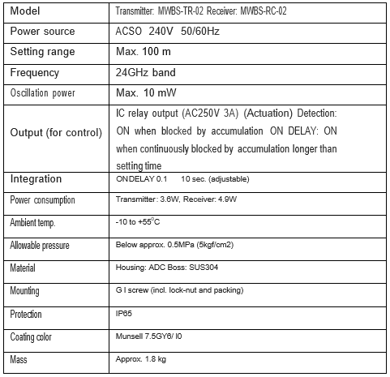

**3. Results and Discussion**

3.1 Analysis of Addition of Plugging Sensor

3.1.1. Condition Before Modification

From the data of plugging incidents occurring during 2014, there is a total disruption of plugging on coal pulverizer inlets or coal feeder outlets in each unit as follows :

Table 3.1 Plugging Disorder In Inlet Coal Pulverizer Unit 2

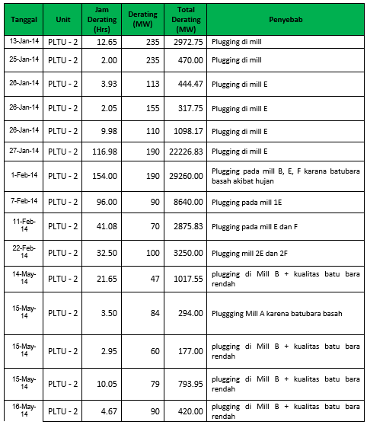

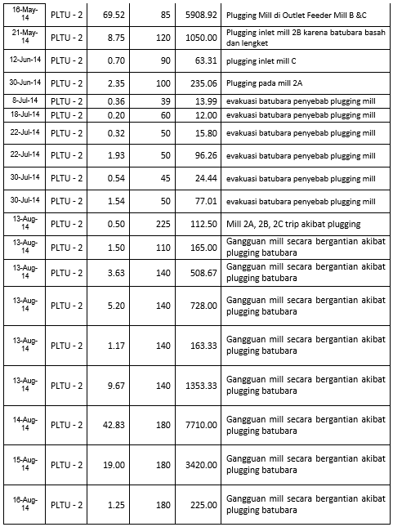

In unit 2 is the most common plugging noise. Until August 2014 alone has as much as 34 times the incidence of plugging and intensity there every month.

* + 1. Condition After Modification

The following will be discussed about the conditions after installation of the plugging sensors in each unit. From derating derating statements, for units 1 and 3 after the addition of sensors, no more plugging interruptions in coal pulverizer inlets or at coal feeder outlets until March 2015. Unlike the number 2 units, there are 9 interruptions plugging. The data below is the data of plugging interference on unit 2 that is still experienced after the addition of plugging sensors up to March 2015.

Table 3.2 Plugging Disorders on Unit 2 After Modification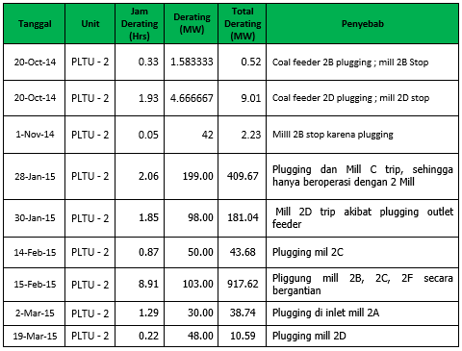

* 1. Assumption of Loss Calculation Before and After Modification

From the data of plugging events in coal pulverizer inlet or coal feeder outlet, it can be used as a basis for calculating production losses before and after modification. It is assumed that the price of operations and maintenance during January 2014 to March 2015 is Rp. 760,-/kWH.

**Production Loss = MW Interference x Hfix**  
Where :

MW Disorder = Derating x Duration Disorder  
Derating = Net Capability (DMN) - MW Loss  
Hfix = Operation and Maintenance Price in Rp./Kwh

1. Unit 1 loss before modification (January 2014 - March 2014)  
Production Loss = 37980.6 MW x Rp.760, - / kWh  
 = Rp. 28,865,256,000, -  
2. Unit 2 loss before modification (January 2014 – August 2014)  
Production Loss = 96140.99 MW x Rp.760, - / kWh  
 = Rp. 73.067.099,200, -  
3. Unit 3 losses before modification (January 2014 - August 2014)  
Production Loss = 27992.92 MW x Rp.760, - / kWh  
 = Rp. 21.274.619,200, -

Total production losses experienced Unit 1, 2, and 3 before the modification of Rp. 123.206.974.400, -

From the condition data after modification, the incident of plugging inlet coal pulverizer / outlet coal feeder only repeated in Unit 2. Here the losses still experienced in Unit 2.  
  
1. Unit 2 loss after modification (August 2014 - March 2015)  
Production Loss = 1613.1 MW x Rp.760, - / kWh  
 = Rp. 1,225,956,000, -

1. **Conclusion**

After seeing the results of the analysis, it can be concluded several things, namely :  
1. Factors that can lead to plugging in PLTU Indramayu include low quality coal, construction of coarse and rusty coal pulp inlet on the inside of the pipe, and incorrect plugging sensor location.  
2. The process of modifying the addition of coal plugging coal inlet coal pulverizer is one form of Failure Defense Task Root Cause Failure Analysis (RCFA) problem of coal plugging problem to overcome, eliminate, minimize the problem of plugging.  
3. Based Based on the assumption of the calculation of losses before and after modification of the plugging sensors addition, obtained a very significant value of losses decreased. Prior to modification, the losses value of Rp. 123,206,974,400, - but when it has been modified the value of losses suffered down to Rp. 1,225,956,000, -.

**Acknowledgments**

The authors would like to express heartfelt thanks to head of the electrical engineering department and rector of STT-PLN. We also appreciate the PT PJB UBJOM PLTU Indramayu and PT. PLN (Persero) for providing financial support.

**References and Notes**

1. Beijing Power Equipment Group, *Drawings For ZGM113N Coal Mill,* ***(*2008)**.

2. Beijing Power Equipment Group, *Medium Speed Roller Coal Mill*, **(2010).**

3. Enjiniring Component Analyst PLTU Indramayu, *ECP Coal Plugging (Enjineriing Change Proposal),* **(2014)**.

4. Enjiniring Component Analyst PLTU Indramayu, *RCFA Coal Plugging (Root Cause Failure Analysis),* (**2014**).

5. PT. PLN (Persero) Udiklat Suralaya, Jakarta, *Sistem PLTU*, **(2005).**

**Figure captions**

Figure 1 Rusted Pipe Condition.

Figure 2 Coal Plugging At Outlet Coal Feeder.

Figure 3 Outlet Coal Feeder Plugging Sensor.

Figure 4 Condition Plugging On Inlet Pipe Pulverizer.

Figure 5 Plugging Sensor circuit.

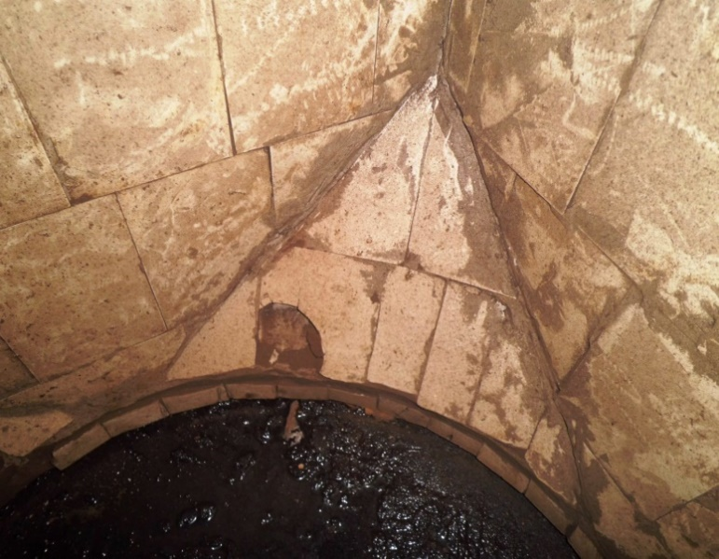

Figure 1. Rusted Pipe Condition

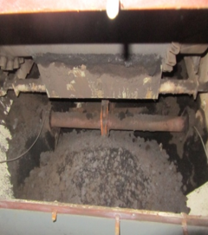

Figure 2. Coal Plugging At Outlet Coal Feeder

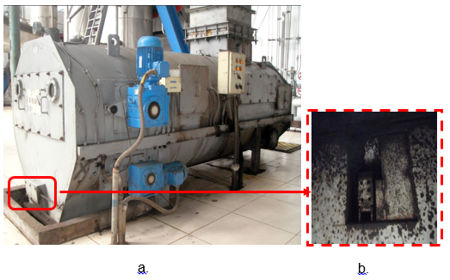

Figure 3. Outlet Coal Feeder Plugging Sensor

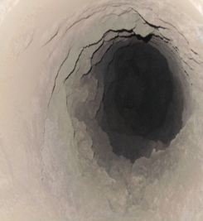

Figure 4. Condition Plugging On Inlet Pipe Pulverizer

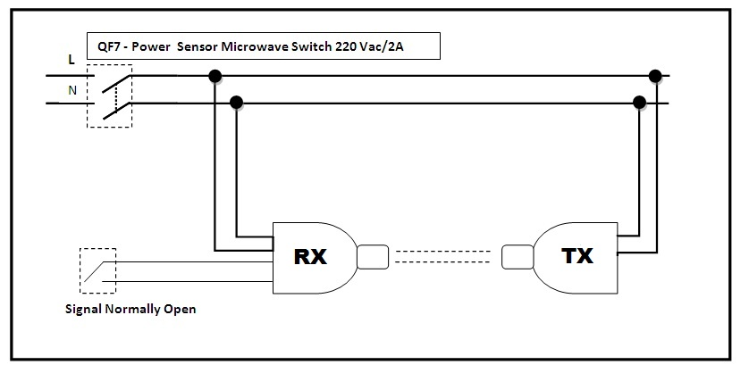

Figure 5. Plugging Sensor circuit