Study Of Optimization Of VRLA And Lithium Batteries For Load Consumption Of Linear And Nonlinear

*Erlina1; Heri Suyanto2Retno Aita Diantari 3**Sofitri Rahayu4*

Faculty of Electricity New and Renewable Energy

Institut Teknologi PLN1,2,3,4

[*erlina@itpln.ac.id*](mailto:erlina@itpln.ac.id) *1*

[*heri.suyanto@itpln.ac.id*](mailto:heri.suyanto@itpln.ac.id) *2*

[*retno.aita@itpln.ac.id*](mailto:retno.aita@itpln.ac.id) *3*

[*sofitri@itpln.ac.id*](mailto:sofitri@itpln.ac.id) *4*

**Abstract.** Solar power plants (PLTS) with an Off-Grid system utilize batteries as a storage medium for energy produced from photovoltaic (PV) modules because the system is not connected to the PLN network. In this study, tests were carried out using VRLA (Valve Regulated Lead Acid) batteries and lithium batteries with linear and non-linear loads and using Polycrystalline and Monocrystalline modules. From the observation of 4 experimental data that we can analyze for a more optimal PLTS system circuit using Monocrystalin solar panels and using Lithium batteries, it is because from the measurement data from 4 experiments the optimal current and voltage for PV absorption and output is greater than that others with the same average irradiation and the same load used. For the load used from several types of linear and non-linear loads with the same capacity of 10 watts which is absorbed more from the battery output, LED lamps are compared to ballast lamps and incandescent lamps (AC). LED lamps because the current flowing is greater than ballast lamps and incandescent lamps. For a longer and optimal battery use Lithium batteries because the current coming out of the lithium is always stable and there is a battery management system on the cells of the lithium battery and input and output from the inverter is more optimal by using lithium batteries. In the Monocrystaline PV module with a peak voltage of 18.2V and a current of 2.54A, on a lithium battery the voltage is 13.8V and a current is 1.8A, the current for the ballast lamp is 0.26A and the incandescent lamp is 0.39 A with the same voltage of 219.2V, in an LED lamp with a voltage of 13.7V and a current of 0.7A.

1. Introduction

**1.1 Background**

Solar power plants (PLTS) with an Off-Grid system utilize batteries as a storage medium for energy produced from photovoltaic (PV) modules because the system is not connected to the PLN network. There are three types of photovoltaic modules with different efficiency levels. Therefore, the output produced from each type of PV module will be different which will affect the output of the components in PV mini-grid considering that the PV module is a generator of electrical energy with the help of solar radiation. The battery that is often used in PV mini-grid systems is a lead-carbon Valve Regulated Lead Acid (VRLA) battery because it has the advantage of having a round-trip efficiency of 90-95% with a deep of discharge (DOD) of 80%, but the drawbacks of this type of battery are: not environmentally friendly because it produces lead acid. Currently, there is Lithium battery technology which is a development of the previous environmentally friendly battery with a pretty good round-trip efficiency of 92-96% and a DOD rate of 100%. From the advantages of these two types of batteries, the author will conduct research on the work system to determine the ratio of linear and non-linear loads that can be measured from Lithium and VRLA batteries using two different types of PV modules for linear and non-linear loads in PLTS Off-Grid available. at the Central Laboratory of Research and Assessment of New and Renewable Energy (P3EBT) IT PLN Jakarta.

**2. METHODS/RESEARCH DESIGN**

**2.1 Research Site**

The location of the research to be carried out at the Central Laboratory of Research and Assessment of New and Renewable Energy (P3EBT) IT PLN Jakarta with the title Study Optimization of the Types of PV Solar Modules on Batteries at Linear and Non-Linear Characteristic Loads using lead-carbon VRLA batteries and Lithium batteries.

**2.2 Research Method**

Research on the need for completion stages. The stages of the research carried out are as follows:

* Literature study, namely collecting data in reference books and journals relevant to the research topic.
* Problem identification, namely by formulating the background of the problem in the research conducted until the objectives of this research are achieved.
* Observation, namely data collection by conducting direct observations at the Central Laboratory of Research and Assessment of New and Renewable Energy (P3EBT) IT-PLN Jakarta to conduct research and learning about the working system of the two batteries connected to PLTS Off Grid.

**2.3 Research flowchart**

In this study, a flow chart is needed for an overview as follows:

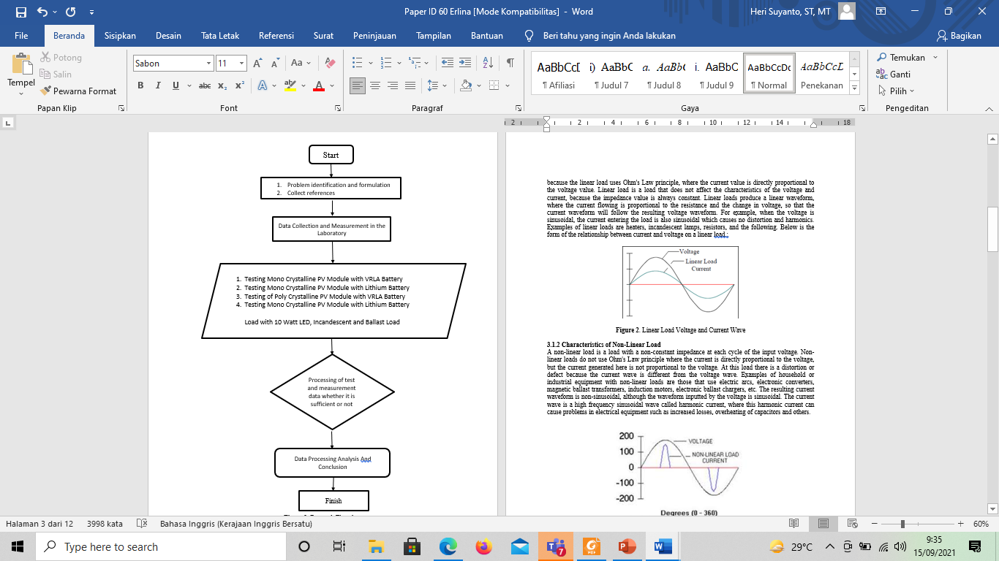

**Figure 1**. Research Flowchart

**3. RESULTS AND DISCUSSION**

**3.1 Linear And Non Linear Load Characteristics**

**3.1.1 Characteristics of Linear Load**

Linear load is a load with a stable impedance that makes the current directly proportional to the voltage at all times. The resulting waveform current will always be the same as the voltage waveform because the linear load uses Ohm's Law principle, where the current value is directly proportional to the voltage value. Linear load is a load that does not affect the characteristics of the voltage and current, because the impedance value is always constant. Linear loads produce a linear waveform, where the current flowing is proportional to the resistance and the change in voltage, so that the current waveform will follow the resulting voltage waveform. For example, when the voltage is sinusoidal, the current entering the load is also sinusoidal which causes no distortion and harmonics. Examples of linear loads are heaters, incandescent lamps, resistors, and the following. Below is the form of the relationship between current and voltage on a linear load :

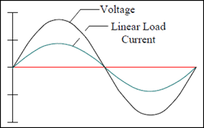

**Figure 2**. Linear Load Voltage and Current Wave

**3.1.2 Characteristics of Non-Linear Load**

A non-linear load is a load with a non-constant impedance at each cycle of the input voltage. Non-linear loads do not use Ohm's Law principle where the current is directly proportional to the voltage, but the current generated here is not proportional to the voltage. At this load there is a distortion or defect because the current wave is different from the voltage wave. Examples of household or industrial equipment with non-linear loads are those that use electric arcs, electronic converters, magnetic ballast transformers, induction motors, electronic ballast chargers, etc. The resulting current waveform is non-sinusoidal, although the waveform inputted by the voltage is sinusoidal. The current wave is a high frequency sinusoidal wave called harmonic current, where this harmonic current can cause problems in electrical equipment such as increased losses, overheating of capacitors and others.

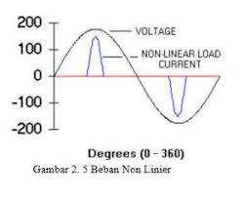

**Figure 3.** Non-linear Load Voltage and Current Wave

**3.2 Data specification of the research components used**

**3.2.1 PV (Photovoltaic)**

The function of the solar module is to convert solar energy into electrical energy as a power plant in the PLTS system. At the time of testing at the Central Laboratory of Research and Assessment of New and Renewable Energy (P3EBT) IT PLN Jakarta used two types of PV (photovoltaic) namely polycrystalline and monocrystaline. In the type of polycristaline using PV with a capacity of 100 Wp.

**Table 1.** Polycristaline Module Specification Data 100 Wp

|  |  |  |  |  |  |  |  |  |  |  |  |  |  |  |  |  |  |  |  |  |  |  |  |  |  |
| --- | --- | --- | --- | --- | --- | --- | --- | --- | --- | --- | --- | --- | --- | --- | --- | --- | --- | --- | --- | --- | --- | --- | --- | --- | --- |
| |  |  |  | | --- | --- | --- | | Subject | Symbol | Value | | Maximum Power | Pmax | 100W | | Voltage at Pmax | Vmp | 17,6V | | Current at Pmax | Imp | 5,70A | | Open-Circuit Voltage | Voc | 22,0V | | Short-Circuit Current | Isc | 6,06A | | Maximum System Voltage |  | 700V | | Temperature Range |  | -45ºC ~ +80ºC | | Polycrystalline solar panel: Best price, features, pros-cons &amp; details |

**Table 2.** Monocrystaline Module Specification Data 100 Wp

|  |  |  |  |  |  |  |  |  |  |  |  |  |  |  |  |  |  |  |  |  |  |  |  |  |  |
| --- | --- | --- | --- | --- | --- | --- | --- | --- | --- | --- | --- | --- | --- | --- | --- | --- | --- | --- | --- | --- | --- | --- | --- | --- | --- |
| |  |  |  | | --- | --- | --- | | Subject | Symbol | Value | | Maximum Power | Pmax | 100W | | Voltage at Pmax | Vmp | 18,1V | | Current at Pmax | Imp | 5,54A | | Open-circuit voltage | Voc | 22,2V | | Short circuit current | Isc | 6,00A | | Max System Voltage |  | 700V | | Temperature Range |  | -45ºC ~+80ºC | | Monocrystalline Solar Panel LG NeON 2 LG355N1C-N5 355Wp |

***3.2.2 Solar Charge Controller (SCC)***

The Solar Charge Controller or SCC in this test is a component that regulates the current andvoltage from the PV module to charge the battery to prevent overcharging or overcharging of the battery which can easily damage the battery, and at night the SCC functions to prevent reverse current from the battery to the PV module. There are two types of Solar Charge Controller (SCC) used here because there are two different types of batteries.

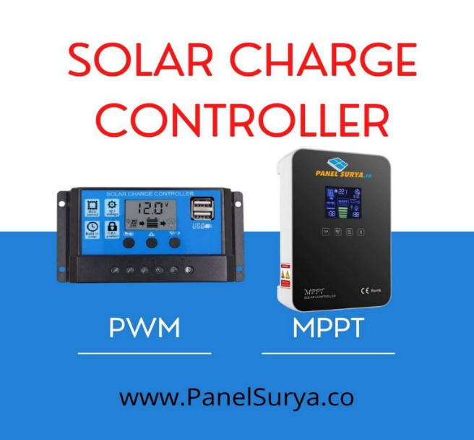

**Figure 4.** Solar Charger Controller (SCC) PWM and MPPT types Baterai

The SCC Lithium battery uses MPPT (Maximum Power Point Tracking) type, while the VRLA battery uses PWM (Pulse Width Modulation) type SCC.

**Table 3.** Data Specifications for Valve Regulated Lead Acid (VRLA) Battery Model JM12-50

|  |  |  |  |  |  |  |  |  |  |  |  |  |  |  |  |
| --- | --- | --- | --- | --- | --- | --- | --- | --- | --- | --- | --- | --- | --- | --- | --- |
| |  |  | | --- | --- | | Subject | Value | | Nominal Voltage | 12V | | Nominal Capacity | 50 Ah | | Charge Current | Max 12,5 ; Recom 5 A | | Equalize Charge | 13,8-14,1 V | | Float Charge | 13,5-13,8 V | | Self Discharge | 3% per month with temperature 25® | |  |

**Table 4.** Data Specifications Lithium-LiFePo4 Battery Model HM50

|  |  |  |  |  |  |  |  |  |  |  |  |  |  |  |  |  |  |  |  |
| --- | --- | --- | --- | --- | --- | --- | --- | --- | --- | --- | --- | --- | --- | --- | --- | --- | --- | --- | --- |
| |  |  | | --- | --- | | Subject | Value | | Nominal Voltage | 12V | | Nominal Capacity | 50 Ah | | Charge Current | 5A | | Applicable Power | 600 W | | Over Charge Protection | 3,2± 0,025 V/Cell | | Over Discharge Protection | 3,2± 0,025 V/Cell | | Over Current Protection | 15 A | | Charge mode | Constant current/ Constant Voltage | |  |

**3.2.3 Off Grid Inverter**

The inverter is an important component in the PLTS system which has the function of converting direct current (DC current) which is the output of the PV module into alternating current (AC current) to be channeled to the load. The inverter in this test is connected to a battery and converts the direct current (DC) that has been stored by the battery and converted into AC current because it uses an AC load.

**Table 5.** Data Specifications Inverter 12 Volt 300 Watt

|  |  |  |  |  |  |  |  |  |  |  |  |  |  |  |  |  |  |
| --- | --- | --- | --- | --- | --- | --- | --- | --- | --- | --- | --- | --- | --- | --- | --- | --- | --- |
| |  |  | | --- | --- | | Parameter | Spesifikasi | | Input Voltage (DC) | 12 V (10-15V) | | Output Voltage (AC) | 220-240V | | Frequency | 50HZ | | Low Battery Alarm | 10,5V +/- 0,5V | | Low Battery Shutdown | 10V +/- 0,5V | | Efficienency | 85~90% | | Thermal Protection | 65˚C +/- 5˚C | |  |

**3.3. Single line diagram of Research Testing**

In this study, we describe a single test in the PV mini-grid circuit that uses two different types of PV, Monocristalin and Polycristaslie and two types of batteries, namely VRLA and Lithium.

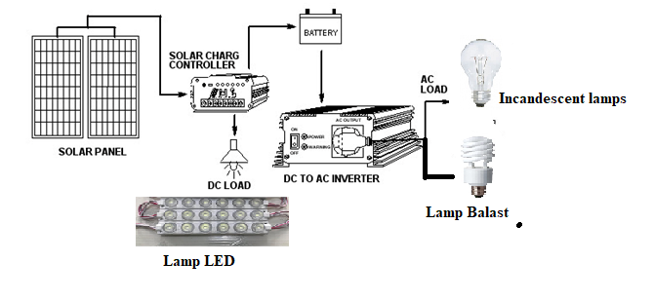

Information :

1. There are two types of Solar Panels Monocrystaline and Polycrystaline

2. There are two types of batteries, VRLA and Lithium

3. DC Loads are LED lamps and incandescent lamps without ballast with a capacity of 10 Watts

4. AC Load is a ballast lamp with a capacity of 10 watts

**Figure 6.** Single Line Research Testing

**3.4 Test results from several experiments in research**

**3.4.1 Test results of Monocrystalline solar with VRLA and Lithium Batteries**

From the test results of Monocrystalin solar panels using VRLA Batteries on Monday, June 14, 2021 from 10.00 to 16.00

**Table 5.** Test Results 1 with Monocrystalline Solar Panels using VRLA Batteries

|  |  |  |  |  |  |  |  |  |  |  |  |
| --- | --- | --- | --- | --- | --- | --- | --- | --- | --- | --- | --- |
| Monday | Irradiation | Solar Panel | | Battery | | Load AC | | Load DC | | Load AC | |
| 14/06/2021 |  | Monocrystalin | | VRLA | | Balast Lamp | | LED Lamp | | fluorescent lamp | |
| O'clock | Watt/m2 | **Volt** | **Amper** | **Volt** | **Amper** | **Volt** | **Amper** | **Volt** | **Amper** | **Volt** | **Amper** |
| 10:00 | 412 | 14.5 | 1.4 | 11.4 | 1.1 | 210.2 | 0.18 | 11.4 | 0.43 | 210.2 | 0.26 |
| 10:30 | 582 | 14.7 | 1.78 | 11.6 | 1.2 | 210.9 | 0.18 | 11.6 | 0.52 | 210.9 | 0.28 |
| 11:00 | 601 | 15.7 | 1.8 | 11.6 | 1.2 | 210.3 | 0.17 | 11.6 | 0.45 | 210.3 | 0.26 |
| 11:30 | 887 | 16.4 | 2.16 | 12 | 1.8 | 212.9 | 0.16 | 12 | 0.5 | 212.9 | 0.27 |
| 12:00 | 923 | 18.1 | 2.4 | 13.5 | 1.9 | 213.2 | 0.24 | 13.5 | 0.6 | 213.2 | 0.25 |
| 12:30 | 980 | 18.2 | 2.54 | 13.6 | 2.0 | 218.2 | 0.24 | 13.7 | 0.6 | 218.2 | 0.28 |
| 13:00 | 847 | 16.1 | 2.33 | 12 | 1.8 | 216.6 | 0.18 | 12 | 0.5 | 216.6 | 0.28 |
| 13:30 | 728 | 17.8 | 2.13 | 12 | 1.8 | 213.4 | 0.18 | 12 | 0.5 | 213.4 | 0.26 |
| 14:00 | 602 | 16.7 | 2.1 | 11.9 | 1.8 | 210.6 | 0.14 | 11.9 | 0.49 | 210.6 | 0.28 |
| 14:30 | 562 | 15.2 | 1.76 | 11.6 | 1.1 | 212.7 | 0.14 | 11.6 | 0.49 | 212.7 | 0.27 |
| 15:00 | 423 | 15.2 | 1.5 | 11.5 | 1.1 | 209.2 | 0.12 | 11.5 | 0.45 | 209.2 | 0.28 |
| 15:30 | 350 | 14.2 | 1.43 | 11.4 | 1 | 208.2 | 0.12 | 11.1 | 0.42 | 208.2 | 0.25 |
| 16:00 | 320 | 14.1 | 0.84 | 11.3 | 1 | 207.9 | 0.10 | 12.1 | 0.41 | 207.9 | 0.25 |

. From the results of testing Monocrystalline solar panels using Lithium Batteries on Monday, June 14, 2021, from 10.00 to 16.00.

**Table 6.** Test Results 2 with Monocrystalline Solar Panels using Lithium Batteries

|  |  |  |  |  |  |  |  |  |  |  |  |
| --- | --- | --- | --- | --- | --- | --- | --- | --- | --- | --- | --- |
| Monday | Irradiation | Solar Panel | | Battery | | Load AC | | Load DC | | Load AC | |
| 14/06/2021 |  | Monocrystalin | | Lithium | | Balast Lamp | | LED Lamp | | fluorescent lamp | |
| O'clock | Watt/m2 | **Volt** | **Amper** | **Volt** | **Amper** | **Volt** | **Amper** | **Volt** | **Amper** | **Amper** | **Volt** |
| 10:00 | 412 | 14.5 | 1.4 | 12.4 | 1.8 | 218.2 | 0.18 | 11.4 | 0.53 | 218.2 | 0.36 |
| 10:30 | 582 | 14.7 | 1.78 | 12.6 | 1.7 | 217.9 | 0.18 | 11.6 | 0.56 | 217.9 | 0.38 |
| 11:00 | 601 | 15.7 | 1.8 | 12.6 | 1.8 | 216.3 | 0.17 | 11.6 | 0.60 | 216.3 | 0.36 |
| 11:30 | 887 | 16.4 | 2.16 | 12.8 | 1.9 | 216.9 | 0.16 | 12 | 0.62 | 216.9 | 0.37 |
| 12:00 | 923 | 18.1 | 2.4 | 13.5 | 1.8 | 217.2 | 0.24 | 13.5 | 0.62 | 217.2 | 0.35 |
| 12:30 | 980 | 18.2 | 2.54 | 13.8 | 1.8 | 219.2 | 0.26 | 13.7 | 0.70 | 2192 | 0.39 |
| 13:00 | 847 | 16.1 | 2.33 | 13.6 | 1.9 | 217.6 | 0.18 | 12 | 0.68 | 217.6 | 0.38 |
| 13:30 | 728 | 17.8 | 2.13 | 12.8 | 1.8 | 216.4 | 0.18 | 12 | 0.69 | 216.4 | 0.36 |
| 14:00 | 602 | 16.7 | 2.1 | 11.9 | 1.8 | 217.6 | 0.14 | 11.9 | 0.65 | 217.6 | 0.38 |
| 14:30 | 562 | 15.2 | 1.76 | 11.8 | 1.7 | 218.7 | 0.14 | 11.6 | 0.58 | 218.7 | 0.37 |
| 15:00 | 423 | 15.2 | 1.5 | 11.8 | 1.8 | 216.2 | 0.12 | 11.5 | 0.52 | 216.2 | 0.38 |
| 15:30 | 350 | 14.2 | 1.43 | 11.6 | 1.9 | 215.2 | 0.12 | 11.1 | 0.50 | 215.2 | 0.35 |
| 16:00 | 320 | 14.1 | 0.84 | 11.8 | 1.8 | 214.9 | 0.10 | 12.1 | 0.49 | 214.9 | 0.35 |

From the table above, Experiment 1 uses Monocrystalin Solar Panels using VRLA Batteries from these data. For peak irradiation at 12.00 – 13.00 at 980 w/m2 irradiation with battery charging with a current of 2 Amperes and a voltage of 13.6 Volts and output voltage from the Inveter 218, 2 Volts are absorbed by the AC load of the ballast lamp of 0.24 amperes and 0.28 amperes of incandescent lamps and 0.6 amperes of DC load for LED lamps. From the table above, Experiment 2 at the same time as Experiment 1 but now using a different Lithium battery. From these data, the peak irradiation is 12.00 – 13.00 at 980 w/m2 irradiation with battery charging with a current of 1.8 Amperes and a voltage of 13.8 Volts. The output voltage from the Inveter 219, 2 Volts is absorbed by the AC load of the Ballast Lamp of 0.26 Ampere and the Incandescent Lamp 0.39 Amperes and the DC Load of the LED Lamp is 0.7 amperes.

**3.4.2 Test results of Polycrystalline solar with VRLA and Lithium Batteries**

From the results of testing Polycrystalline solar panels using VRLA Batteries on Tuesday, June 15, 2021, from 10.00 to 16.00

**Table 7.** Test Results 3 with Polycrystalline Solar Panels using VRLA Batteries

|  |  |  |  |  |  |  |  |  |  |  |  |  |  |
| --- | --- | --- | --- | --- | --- | --- | --- | --- | --- | --- | --- | --- | --- |
| Tuesday | Irradiation | Solar Panel | | Battery | | Load AC | | Load DC | | | Load AC | | |
| 15/06/2021 |  | Monocrystalin | | VRLA | | Balast Lamp | | LED Lamp | | | fluorescent lamp | | |
| O'clock | Watt/m2 | **Volt** | **Amper** | **Volt** | **Amper** | **Volt** | **Amper** | | **Volt** | **Amper** | **Amper** | **Volt** |
| 10:00 | 446 | 14.6 | 1.4 | 12.2 | 1.3 | 210.4 | 0.10 | | 11.4 | 0.33 | 210.4 | 0.14 |
| 10:30 | 568 | 14.8 | 1.78 | 12.4 | 1.4 | 210.4 | 0.11 | | 11.6 | 0.32 | 210.4 | 0.15 |
| 11:00 | 634 | 15.2 | 1.8 | 12.6 | 1.8 | 210.6 | 0.14 | | 11.6 | 0.35 | 210.6 | 0.18 |
| 11:30 | 856 | 15.8 | 2.16 | 12.8 | 1.6 | 212.8 | 0.16 | | 12 | 0.3 | 212.8 | 0.21 |
| 12:00 | 921 | 16.6 | 2.4 | 13.2 | 1.7 | 214.6 | 0.18 | | 13.1 | 0.3 | 214.6 | 0.22 |
| 12:30 | 986 | 16.8 | 2.54 | 13.4 | 1.8 | 217.8 | 0.21 | | 13.2 | 0.4 | 217.8 | 0.24 |
| 13:00 | 846 | 16.4 | 2.33 | 13.1 | 1.7 | 216.6 | 0.18 | | 12 | 0.4 | 216.6 | 0.22 |
| 13:30 | 758 | 16.0 | 2.13 | 12.8 | 1.6 | 213.4 | 0.18 | | 12 | 0.3 | 213.4 | 0.20 |
| 14:00 | 721 | 15.8 | 2.1 | 12.7 | 1.5 | 210.6 | 0.14 | | 11.9 | 0.39 | 210.6 | 0.18 |
| 14:30 | 580 | 14.8 | 1.76 | 12.6 | 1.4 | 212.7 | 0.14 | | 11.6 | 0.39 | 212.7 | 0.17 |
| 15:00 | 446 | 14.6 | 1.5 | 12.5 | 1.3 | 209.4 | 0.12 | | 11.5 | 0.35 | 209.4 | 0.16 |
| 15:30 | 428 | 14.3 | 1.43 | 12.4 | 1.3 | 208.2 | 0.12 | | 11.1 | 0.32 | 208.2 | 0.14 |
| 16:00 | 420 | 14.2 | 0.84 | 12.4 | 1.2 | 206.9 | 0.10 | | 12.1 | 0.31 | 206.9 | 0.14 |

**Table 8.** Test Results 4 with Polycrystalline Solar Panels using Lithium Batteries

|  |  |  |  |  |  |  |  |  |  |  |  |
| --- | --- | --- | --- | --- | --- | --- | --- | --- | --- | --- | --- |
| Tuesday | Irradiation | Solar Panel | | Battery | | Load AC | | Load DC | | Load AC | |
| 15/06/2021 |  | Monocrystalin | | Lithium | | Balast Lamp | | LED Lamp | | fluorescent lamp | |
| O'clock | Watt/m2 | **Volt** | **Amper** | **Volt** | **Amper** | **Volt** | **Amper** | **Volt** | **Amper** | **Amper** | **Volt** |
| 10:00 | 446 | 14.6 | 1.4 | 12.2 | 1.3 | 210.4 | 0.10 | 11.4 | 0.33 | 210.4 | 0.14 |
| 10:30 | 568 | 14.8 | 1.78 | 12.4 | 1.4 | 210.4 | 0.11 | 11.6 | 0.32 | 210.4 | 0.15 |
| 11:00 | 634 | 15.2 | 1.8 | 12.6 | 1.5 | 210.6 | 0.14 | 11.6 | 0.35 | 210.6 | 0.18 |
| 11:30 | 856 | 15.8 | 2.16 | 12.8 | 1.5 | 212.8 | 0.16 | 12 | 0.3 | 212.8 | 0.21 |
| 12:00 | 921 | 16.6 | 2.4 | 13.2 | 1.6 | 215.6 | 0.18 | 12.9 | 0.3 | 215.6 | 0.21 |
| 12:30 | 986 | 16.8 | 2.54 | 13.4 | 1.6 | 216.8 | 0.20 | 13.0 | 0.4 | 216.8 | 0.22 |
| 13:00 | 846 | 16.4 | 2.33 | 13.1 | 1.5 | 215.6 | 0.18 | 12.8 | 0.4 | 215.6 | 0.21 |
| 13:30 | 758 | 16.0 | 2.13 | 12.8 | 1.5 | 213.4 | 0.18 | 12.6 | 0.3 | 213.4 | 0.20 |
| 14:00 | 721 | 15.8 | 2.1 | 12.7 | 1.5 | 210.6 | 0.14 | 11.9 | 0.39 | 210.6 | 0.18 |
| 14:30 | 580 | 14.8 | 1.76 | 12.6 | 1.4 | 212.7 | 0.14 | 11.6 | 0.39 | 212.7 | 0.17 |
| 15:00 | 446 | 14.6 | 1.5 | 12.5 | 1.3 | 209.4 | 0.12 | 11.5 | 0.35 | 209.4 | 0.16 |
| 15:30 | 428 | 14.3 | 1.43 | 12.4 | 1.3 | 208.2 | 0.12 | 11.1 | 0.32 | 208.2 | 0.14 |
| 16:00 | 420 | 14.2 | 0.84 | 12.4 | 1.2 | 206.9 | 0.10 | 12.1 | 0.31 | 206.9 | 0.14 |

**3.5 Testing Analysis of several experiments in research**

From the 4 experimental data that we can analyze for a more optimal PLTS system circuit using Monocrystalin solar panels and using Lithium batteries because of the measurement data from 4 experiments the optimal current and voltage for PV absorption and output is greater than the others. with the same average irradiation and the same load used. For loads that are used from several types of linear and non-linear loads with the same capacity of 10 watts which are absorbed more from the battery output are non-linear loads (Balast lamps and Incandescent lamps (AC) compared to LED lamps. AC lamps because the current flowing is more larger than others such as ballast lamps and incandescent lamps.

For a longer and optimal battery use Lithium batteries because the current coming out of the lithium is always stable and there is a battery management system on the cells of the lithium battery and input and output from the inverter is more optimal by using lithium batteries.

**4. CONCLUSIONS AND SUGGESTIONS**

**From the research and writing above we can conclude that:**

1. In research to find optimization on solar panels and batteries used in the PLTS system, we can do 4 experiments, namely:

* On the first day with the first and second experiments at the same time the PLTS circuit with Monocrystalin solar panels with VRLA batteries (experiment 1) and Lithium (experiment 2) with Linear Loads such as LED lamps (DC lamps) 10 watts and non-linear loads such as ballast lamps and Incandescent Lamp (AC Lamp).
* On the second day with the third and fourth experiments at the same time the PLTS circuit with Polycrystalin solar panels with VRLA batteries (experiment 3) and Lithium (experiment 4) with Linear Loads such as LED lamps (DC lamps) 10 watts and non-linear loads such as ballast lamps and Incandescent Lamp (AC Lamp)

1. From the observation of 4 experimental data that we can analyze for a more optimal PLTS system circuit using Monocrystalin solar panels and using Lithium batteries because of the measurement data from 4 experiments the optimal current and voltage for absorption and pv output is greater in compare others with the same average irradiation and the same load used
2. For loads that are used from several types of linear and non-linear loads with the same capacity of 10 watts which are absorbed more from the battery output are non-linear loads (Balast lamps and Incandescent lamps (AC) compared to LED lamps. AC lamps because of the current flow is greater than others such as ballast lamps and incandescent lamps.
3. For a longer and optimal battery use Lithium batteries because the current coming out of the lithium is always stable and there is a battery management system on the cells of the lithium battery and the input and output of the inverter is more optimal by using lithium batteries.

**REFERENCES**

[1] N. Nitta, F. Wu, J.T. Lee, G. Yushin **Li-ion battery materials: present and future** Mater Today, 18 (5) (2015), pp. 252-264, [10.1016/j.mattod.2014.10.040](https://doi.org/10.1016/j.mattod.2014.10.040)

[2] M. Shahriari and M. Farrokhi, "Online state-of-health estimation of VRLA batteries using state of charge", IEEE Trans. Ind. Electron., vol. 60, no. 1, pp. 191-202, Jan. 2013

[3] J. Xue, J. Ye, Q. Tao, *et al.* Economic feasibility of user-side battery energy storage based on whole-life-cycle cost model Power System Technology, 40 (08) (2016), pp. 2471-2476

[4] S. Lavety, R. Keshri, S. Ghosh and M. A. Chaudhari, "Non-Linear Model and Parameter Extraction for Charge/discharge Behavior of Valve Regulated Lead-Acid Battery," in IEEE Transactions on Energy Conversion, doi: 10.1109/TEC.2021.3062087.

[5] Shaukat, N., Khan, B, Ali, S.M, et al. A survey on electric vehicle transportation within smart grid system. Renewable Sustainable Energy Rev. 2017; 81: 1329-1349

[6] B. Wang, *et al.* Improving hosting capacity of unbalanced distribution networks via robust allocation of battery energy storage systems IEEE Transactions on Power Systems, 1 (1) (2020)